Creating an inclusive school environment in which all languages, including all home languages, are valued.

  - How can we foster positive attitudes towards language diversity among colleagues and learners?
  - In which ways can reflection on one’s own language biography promote professional development in respect to a plurilingual and intercultural dimension?
  - How can we develop learning environments where all languages are valued and actively used for learning? What do we need to consider?
  - What kind of activities and settings do we have to provide? At which level?

Exemplar classroom resource 1:

Working with PEPELINO, a tool for self-reflection on the plurilingual and intercultural dimension, which can be used in teacher education (pre-primary and primary level).

Task: Reflection on own attitudes and professional competences by means of descriptors selected from the portfolio (see below).
Choose for each descriptor at least one question which seems relevant to you and relate it to your own practice. Discuss with colleagues and/or write your thoughts in a learning diary*.

Section I: “Analysing and adapting how to talk to children”, descriptors 2 and 5

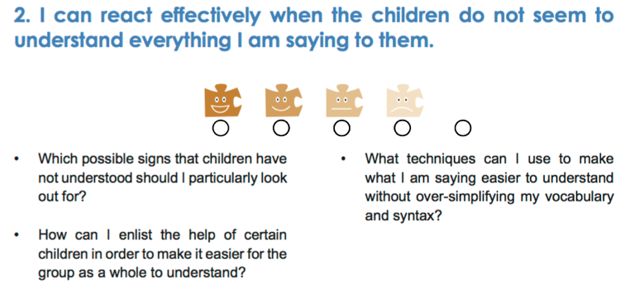

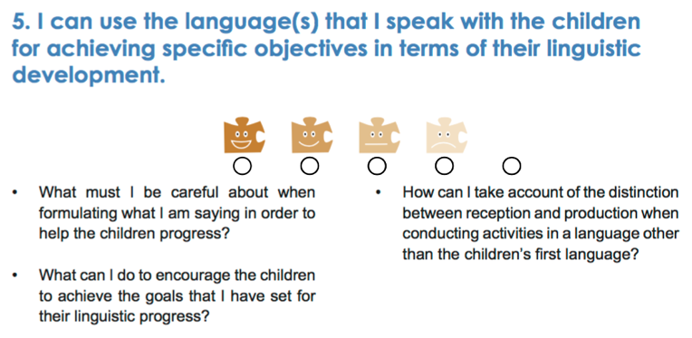

Section II: “Responding positively to linguistic and cultural diversity”, descriptor 2

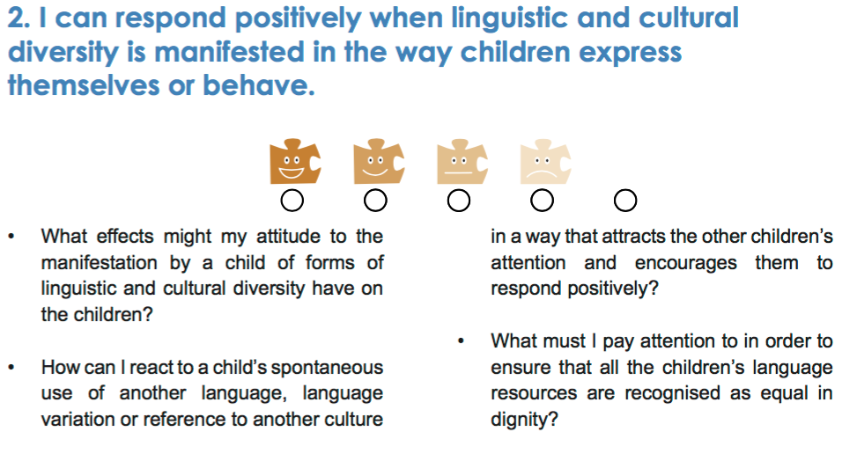

Section VI: “Supporting the linguistic development of children with other first languages, descriptor 3

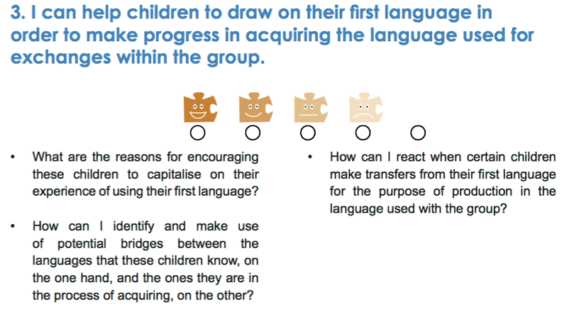

*Why is it important to record your thoughts on languages?
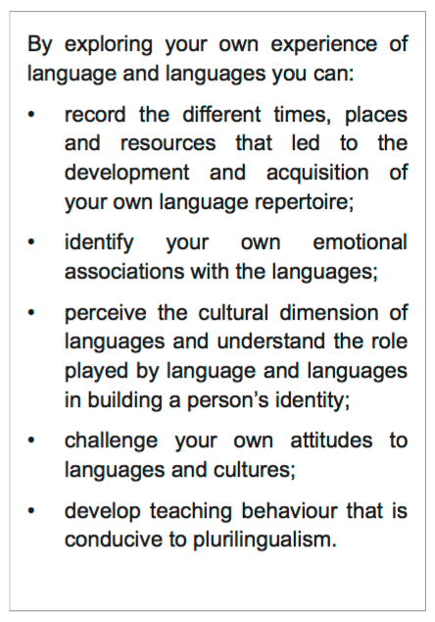

Source : PEPELINO website – European portfolio for pre-primary educators: The plurilingual and intercultural dimension.

Possible objectives for teacher-learners:
Develop positive attitudes towards plurilingual education and increase one’s own language awareness.
Focus on own professional development and become more confident in the multilingual classroom.
Identify strategies for supporting plurilingual education and including the first languages of the students as a resource.
Support school development with regard to languages.

Exemplar classroom resource 2:

Task 1: How to implement whole school language curricula?
You can find a list of recommended factors below. Please choose the two most challenging ones in your opinion and discuss the following questions with your colleagues:

- How would you assess the situation in your own professional context?
- What would you like to change?
- What could be the next step?

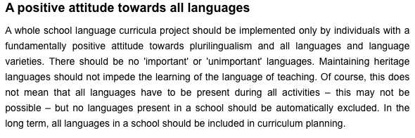

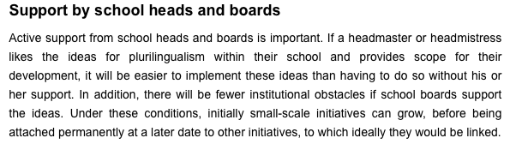

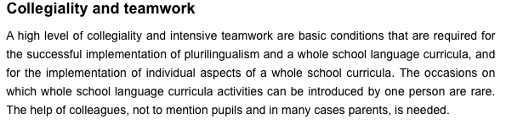

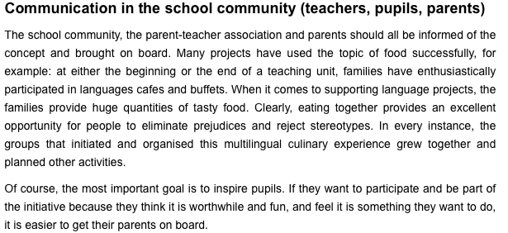

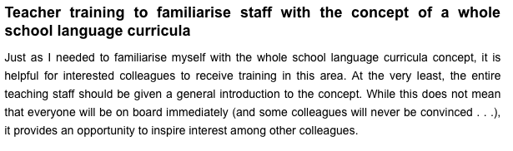

Source: PlurCur website, Towards whole school language curricula - Success factors for the implementation of whole school language curricula.

Task 2: Example of whole school plurilingual approaches in Dublin
Déirdre Kirwan, Ireland

Listen to the video and reflect on the following questions:
- What do you find is the most remarkable in this example?
- What kinds of activities have been successful implemented?
- Which principles and strategies can you identify?
- (How) could this be transferred to your school?

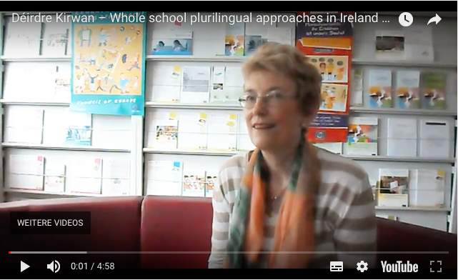

Source : PlurCur website – Video of good practice (4’58”)
Keywords: valuing all languages, literacy, autonomous learning, teachers as learners

Possible objectives for teacher-learners:
Become familiar with whole school approaches, taking the language dimension into account in all subjects.
Develop school principles for creating learning environments, in which all languages are valued (What does matter?)
Consider strategies towards whole school language curricula and get support for own school context.

Reflective questions:
How do these resources address the initial questions?
How do learners benefit from them?
What other objectives could you achieve with these activities?
How would you use these resources and adapt them for your own context?

Food for thought:
MALEDIVE website - School language profile (Brigitta Busch, University of Vienna, AT)
MALEDIVE website– Language biographies – Approaches to multilingualism in education (Brigitta Busch, University of Vienne, AT)
EOL Working Platform – Learning environments where modern languages flourish - Matrix
CARAP: pluralistic approaches

Other resources:
MALEDIVE website – Learner profiles
MALEDIVE website – Many roots, many voices (Ontario, CA)
MARILLE website - https://www.youtube.com/watch?v=C874sN1_1WA , (second video, ‘French example’) video by Nathalie Auger showing a primary school teacher working with his learners’ languages (in French with English subtitles)
References:
Perceiving and managing linguistic diversity in education; H.-J. Krumm, H.-H. Reich, 2011. https://bimm.at/publikationen/curriculum-mehrsprachigkeit/ (in German)
https://www.coe.int/en/web/language-policy/a-handbook-for-curriculum-development-and-teacher-training.-the-language-dimension-in-all-subjects – A handbook for curriculum development and teacher training; J.-C. Beacco, M. Fleming, F. Goullier, E. Thürmann, H. Vollmer; Council of Europe, 2015.

